|  |
| --- |
| SFU |
| STAT 485 Assignment 4 |
| Kun Yang 301178299 |

|  |
| --- |
|  |

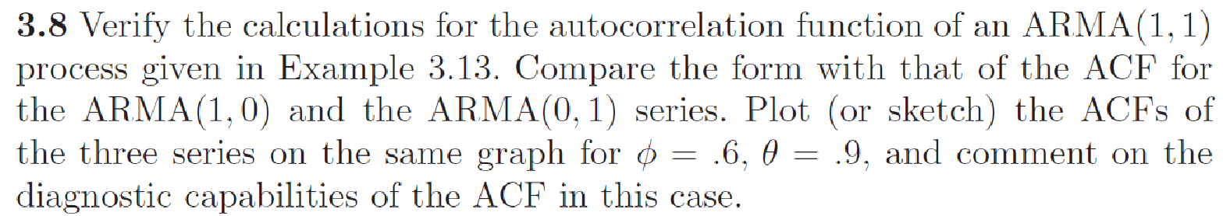

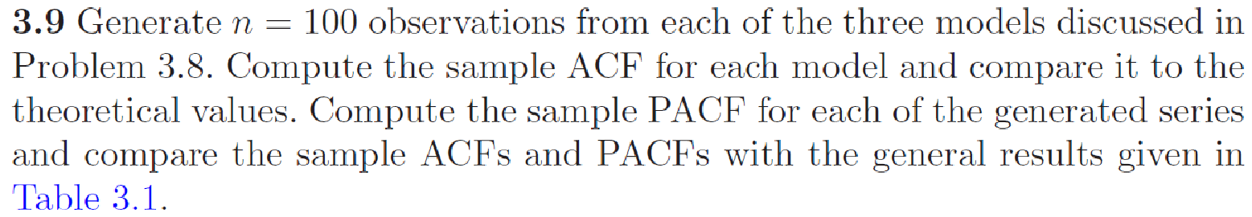

> AR1=arima.sim(model=list(ar=0.6),n=100)

> acf(AR1,lag.max=20)

> pacf(AR1,lag.max=20)

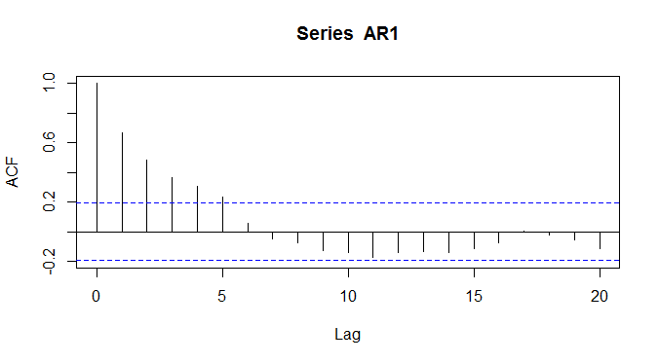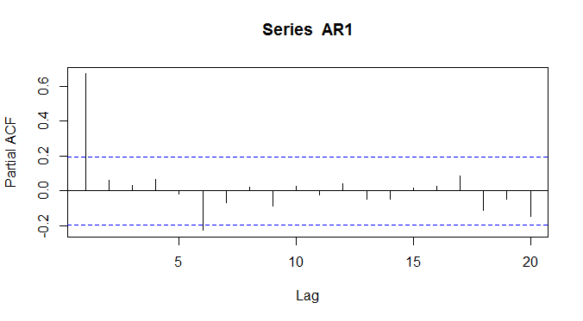

> MA1=arima.sim(model=list(ma=0.9),n=100)

> acf(MA1,lag.max=20)

> pacf(MA1,lag.max=20)

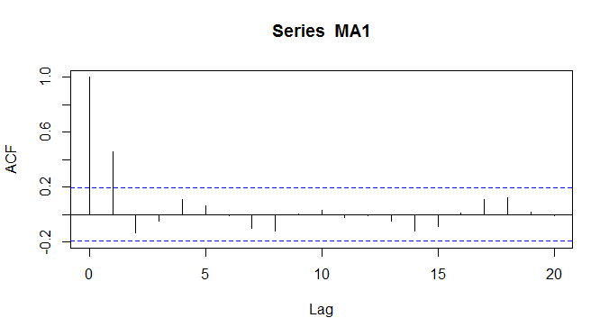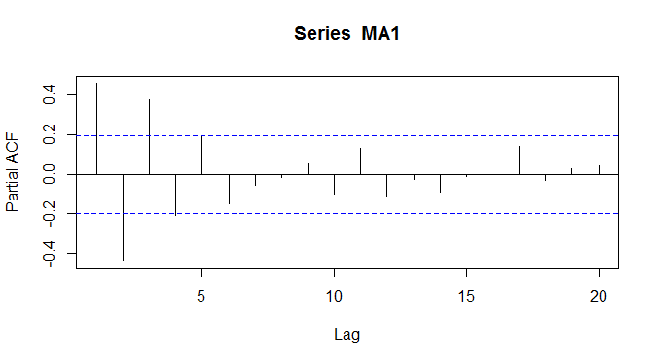

> ARMA1=arima.sim(model=list(ar=0.6,ma=0.9),n=100)

> acf(ARMA1,lag.max=20)

> pacf(ARMA1,lag.max=20)

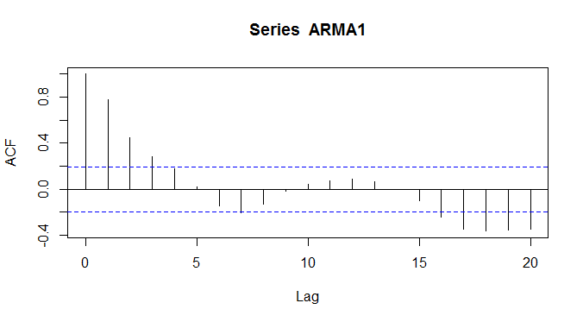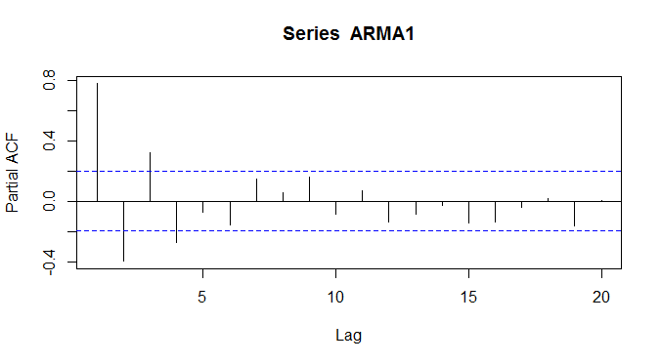

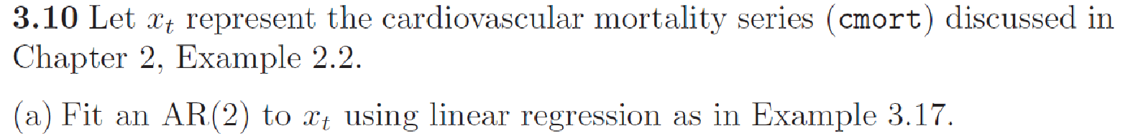

> library("astsa")

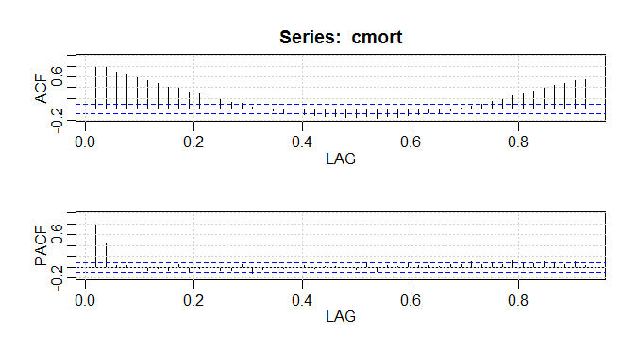> acf2(cmort, 48)

ACF PACF

[1,] 0.77 0.77

[2,] 0.77 0.44

[3,] 0.68 0.03

[47,] 0.53 0.11

[48,] 0.55 0.02

> (regr = ar.ols(cmort, order=2, demean=FALSE, intercept=TRUE))

Call:

ar.ols(x = cmort, order.max = 2, demean = FALSE, intercept = TRUE)

Coefficients:

1 2

0.4286 0.4418

Intercept: 11.45 (2.394)

Order selected 2 sigma^2 estimated as 32.32

> regr$asy.se.coef

$x.mean

[1] 2.393673

$ar

[1] 0.03979433 0.03976163

> regr$var.pred

[,1]

[1,] 32.31749

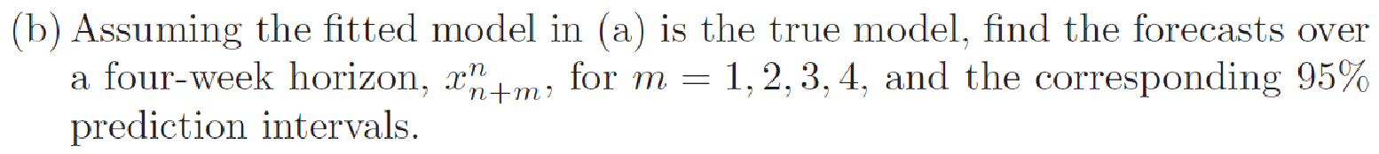

> (fore = predict(regr, n.ahead=4))

$pred

Time Series:

Start = c(1979, 41)

End = c(1979, 44)

Frequency = 52

[1] 87.59986 86.76349 87.33714 87.21350

$se

Time Series:

Start = c(1979, 41)

End = c(1979, 44)

Frequency = 52

[1] 5.684848 6.184973 7.134227 7.593357

> ts.plot(cmort, fore$pred, xlim=c(1979,1980), ylab="cardiovascular mortality")

> lines(fore$pred, type="p", col=2)

> lines(fore$pred+1.96*fore$se, lty="dashed", col=4)

> lines(fore$pred-1.96*fore$se, lty="dashed", col=4)

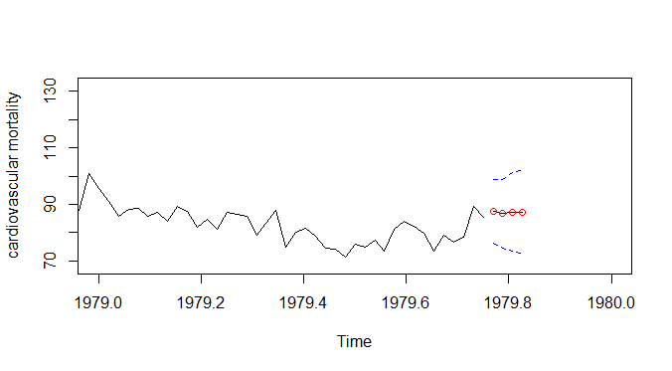

> fore$pred+1.96*fore$se

Time Series:

Start = c(1979, 41)

End = c(1979, 44)

Frequency = 52

[1] 98.74217 98.88604 101.32022 102.09648

> fore$pred-1.96*fore$se

Time Series:

Start = c(1979, 41)

End = c(1979, 44)

Frequency = 52

[1] 76.45756 74.64094 73.35405 72.33052

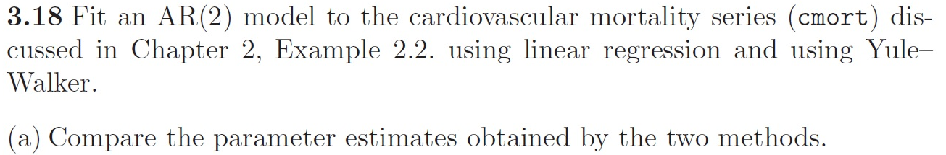

> (regr = ar.ols(cmort, order=2, demean=FALSE, intercept=TRUE))

Call:

ar.ols(x = cmort, order.max = 2, demean = FALSE, intercept = TRUE)

Coefficients:

1 2

0.4286 0.4418

Intercept: 11.45 (2.394)

Order selected 2 sigma^2 estimated as 32.32

> (regr2=ar.yw(cmort,order=2, demean=TRUE, intercept=TRUE))

Call:

ar.yw.default(x = cmort, order.max = 2, demean = TRUE, intercept = TRUE)

Coefficients:

1 2

0.4339 0.4376

Order selected 2 sigma^2 estimated as 32.84

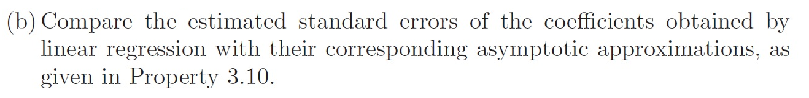

> regr$asy.se.coef

> regr2$asy.se.coef

NULL

> regr2$var.pred

[1] 32.84056

$x.mean

[1] 2.393673

$ar

[1] 0.03979433 0.03976163

> regr$var.pred

[,1]

[1,] 32.31749